Wilson Umpire Face Mask
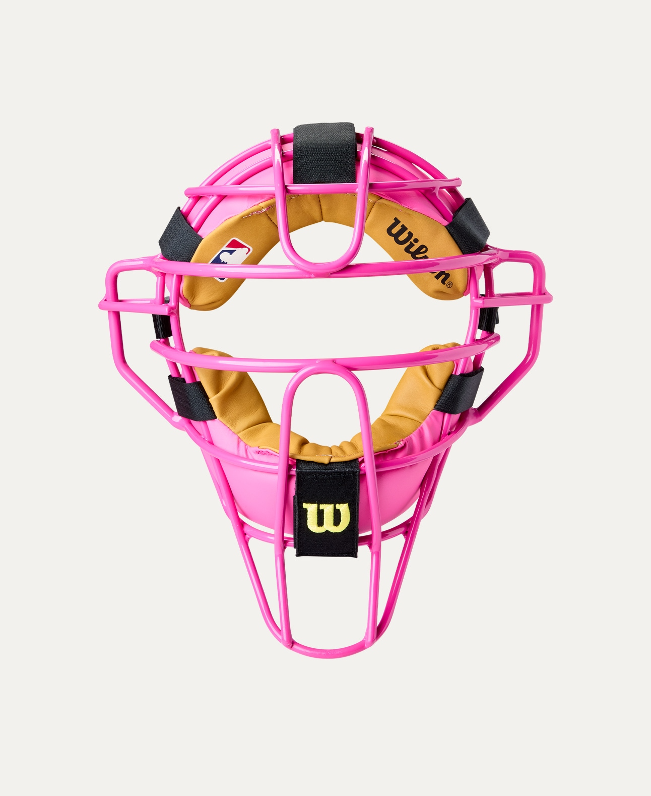
Price: Approximately Rs 10,000

Introduction
The Wilson Umpire Face Mask is designed to provide maximum facial protection and comfort for baseball and softball umpires. Built to meet professional safety standards, it ensures confidence and security behind the plate.

Product Overview
This Wilson Umpire Face Mask offers reliable protection against fast pitches and foul tips. Its lightweight yet strong construction allows clear visibility and comfort during long hours of officiating.

About the Brand
Wilson is a globally trusted sports brand known for producing professional-grade baseball equipment. Wilson umpire gear is widely used in leagues and tournaments for its safety, durability, and performance.

Key Features
- Full-face protection for umpires
- Lightweight yet strong frame
- Padded interior for impact absorption
- Wide field of vision
- Adjustable harness for secure fit

Design & Build Quality
The mask features a sturdy steel or alloy frame with a low-profile design to improve visibility. High-density padding ensures comfort while reducing impact from high-speed balls.

Storage & Capacity
Compact and easy to store in sports or umpire gear bags without taking up excessive space.

Material & Durability
Constructed from high-quality steel or alloy with moisture-resistant padding, the Wilson Umpire Face Mask is built to withstand repeated impacts and long-term use.

Ideal For
- Baseball umpires
- Softball umpires
- Professional and amateur leagues
- Training and competitive matches

Care Instructions
- Wipe frame with a dry or damp cloth
- Air dry padding after use
- Avoid dropping or heavy impact when not in use
- Store in a protective gear bag

Product Specifications
- Brand: Wilson
- Product Type: Umpire Face Mask
- Frame Material: Steel / Alloy
- Padding: High-density foam
- Fit Type: Adjustable
- Usage: Baseball & Softball Officiating

Product Summary
The Wilson Umpire Face Mask provides dependable protection, comfort, and visibility for umpires. With durable construction and professional design, it is an essential safety accessory for officiating baseball and softball games.

Thank you

